2 to 1 MUX 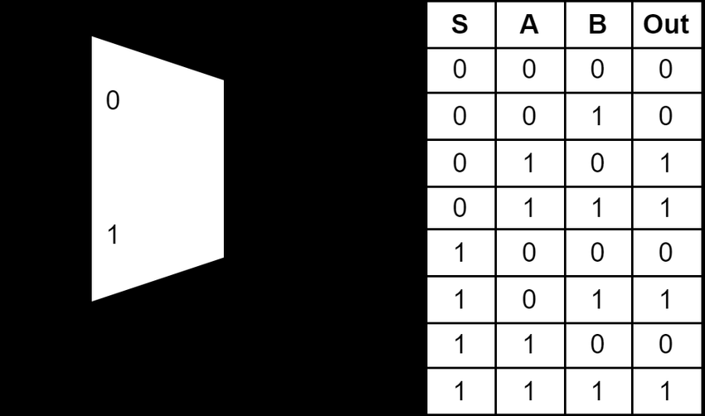

Using Fredkin gate

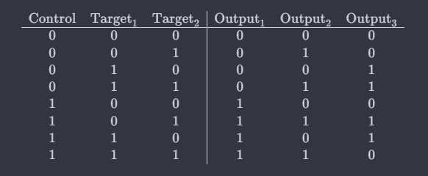

statevector, bloch diagram, tensor product, inner product, outer product --- Note

2. 2X1 MUX realization -> 4X1 MUX

upto chapter 4; nielson chapter 2

TT, KARNOUGH MAP, expression matching with Fredkin gate

ab XOR c

UMANTA CHAKRABORTY

12:06 PM

1. statevector, bloch diagram, tensor proiduct, inner product, outer product --- Note

SUMANTA CHAKRABORTY

12:09 PM

2. 2X1 MUX realization -> 4X1 MUX

upto chapter 4; nielson chapter 2

You

12:11 PM

BEFORE {'010': 486, '011': 538}

You

12:13 PM

AFTER {'010': 498, '101': 526}

SUMANTA CHAKRABORTY

12:15 PM

q0 -> s0

q1 -> b

q2 -> c

SUMANTA CHAKRABORTY

12:17 PM

ab XOR c